function Chai() {

  return <h1>Chai aur React !!</h1>;

}

Chai;

// this is basic component syntax

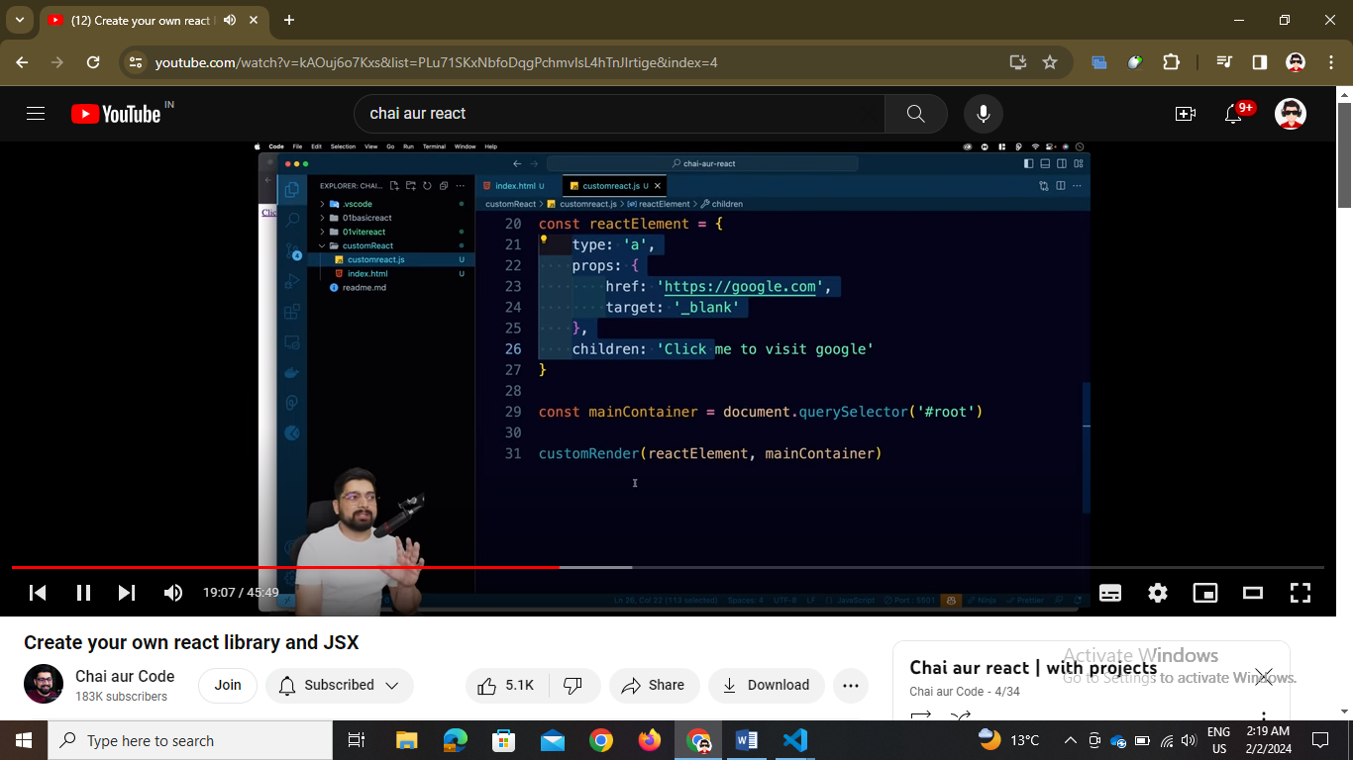

// build custom react

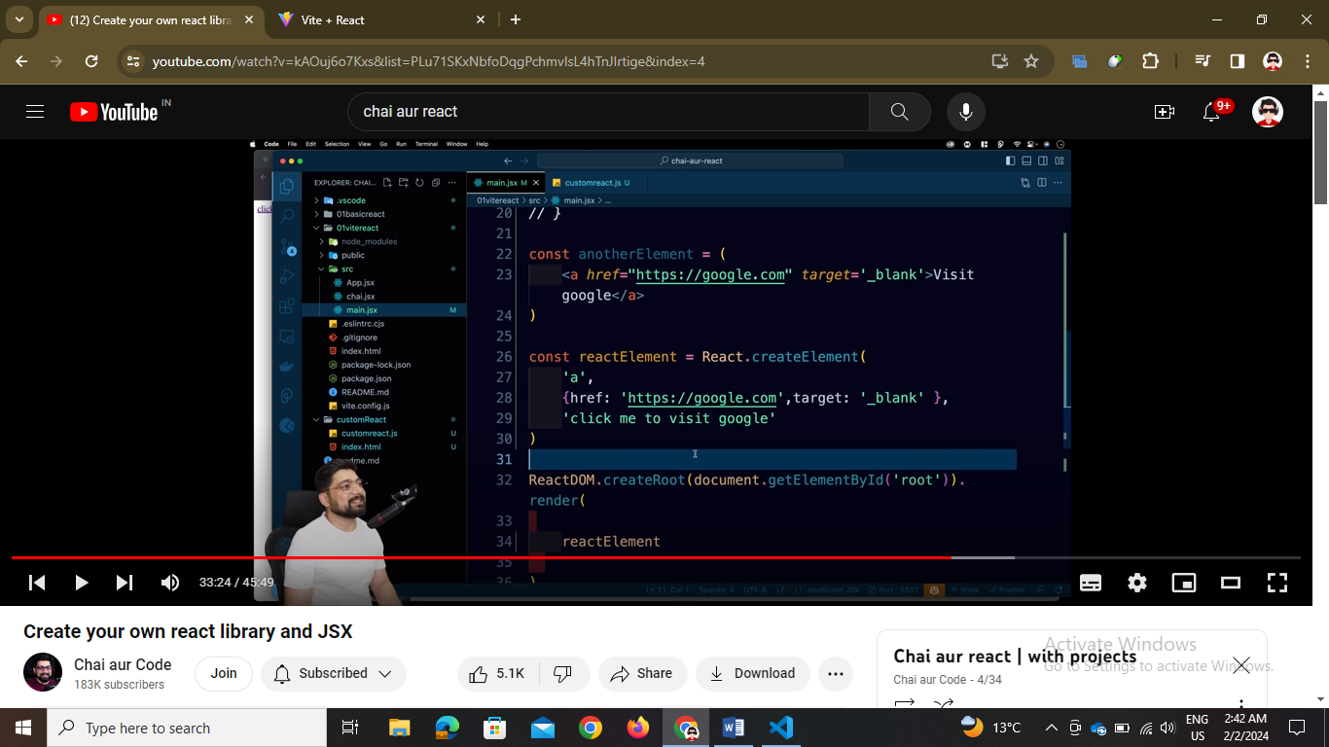

// we can have function and then return mai html

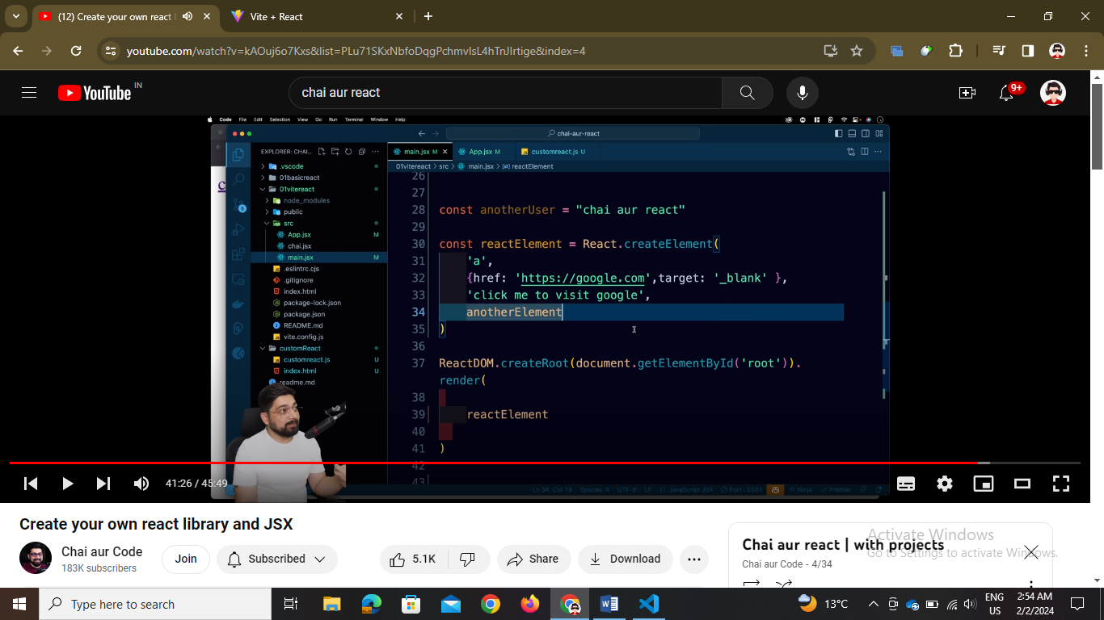

// we can create functions and by createReactElement and then the babel will convert this to js code ..

If you have to use some expression same as it is in jsx use {username}

function App() {

  const name = "Chai aur React !!";

  return <h1>{name}</h1>;

}